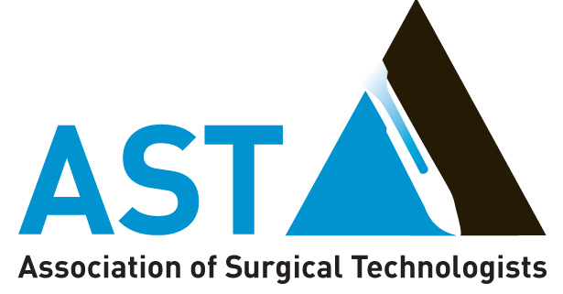
Proclamation
National Surgical Technologists Week

Whereas, for over 60 years, surgical technology has grown to meet the ever-increasing demand for well-educated, highly-skilled and versatile surgical technologists;
WHEREAS, surgical technologists are entrusted with the lives and well-being of patients and provide a critical service during surgical procedures;

WHEREAS, over 90,000 surgical technologists nationwide are an integral part of the surgical team committed to providing the highest quality of surgical care to patients;

Whereas, surgical technologists are responsible for the application of sterile and aseptic technique in the operating room, ensuring that equipment functions properly and facilitating safe and effective conduct during invasive surgical procedures;

WHEREAS, surgical technologists strive to prevent life-threatening surgical site infections and maximize patient safety;

WHEREAS, Certified Surgical Technologists graduate from an accredited program and receive certification conferred by the National Board of Surgical Technology and Surgical Assisting based upon passage of the national examination;

WHEREAS, the surgical technologist’s motto “Aeger Primo, the patient first” reflects total commitment to patient safety and advocacy;

The people of our [“state” or “city”] are honored to join our nation in recognizing National Surgical Technologists Week. NOW, THEREFORE, I, [FIRST NAME] [LAST NAME], [“Governor” or “Mayor”] of the [“State” or “City”] of [STATE OR CITY NAME], do hereby proclaim [“Month”, “Date(s)”, “Year”], as

Surgical Technologists Week

across [“State” or “City”] of [STATE NAME or CITY NAME], and I and urge all my fellow citizens to join me in acknowledging the important role of surgical technologists in the care and recovery of their patients. We honor these men and women whose diligence and professionalism keep the residents of our [STATE OR CITY] safe and healthy.

